Monitoring / On-Call Approval Form

Employee Name: Nikunj Adhaduk _

Manager Name: Vlad Rabenok .
Monitoring Hours
Date of Monitoring (mm/dd/yyyy) | Project | Reason | Number of Hours
Jan 1 – Feb 8, 2024 | Scene+ |  | 16.5
Feb 9, 2024 | Scene+ |  | 3
Feb 9 – Feb 29, 2024 | Scene+ |  | 9
March 5, 2024 | Scene+ |  | 1
March 6, 2024 | Scene+ |  | 2.5
TOTAL |  |  | 32

On-Call Payment
Dates On-Call (mm/dd/yyyy – mm/dd/yyyy) | # of Weeks | Rate
TOTAL
Approvals
Employee Signature:  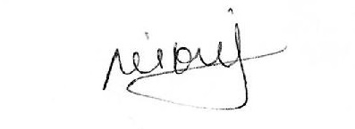 | Date:  March 6, 2024
Manager Signature: | Date:  March 6, 2024

Please submit to Payroll once approved.

Description
Date of Monitoring (mm/dd/yyyy) | Project | Reason
Jan 1 – Feb 8, 2024 | Scene+ | Only counted weekend security incident support and analysis. Counted from easy project timesheet
Feb 9, 2024 | Scene+ | Havas deployment to bring website sign in behind Imperva
Feb 9 – Feb 29, 2024 | Scene+ | Only counted weekend security incident support and analysis
March 5, 2024 | Scene+ | Night deployment support to take BNS processing offline from APIM to service bus.  First deployment on backend service bus only.  Deployment was divided into two parts to mitigate the risk
March 6, 2024 | Scene+ | Night deployment as mentioned above and also had to do rollback due to code issues

